Blinkit Business Intelligence Dashboard
A Data Analysis Project
Manya Kapoor, M.A Economics, DTU
Date: May 2026

Executive Finding
This project presents an end-to-end business intelligence analysis of Blinkit’s operations using 80,000+ records across 5 datasets covering orders, customers, products, and inventory for the period March 2023 to November 2024. The analysis was conducted using Power BI, Excel, SQL, Python to derive actionable business insights.

Key Findings
- Revenue and Seasonality
Total revenue of Rs. 11.01 Million was recorded across 5000 orders. Revenue peaked during October 2024 and December 2023 confirming strong seasonality in quick commerce demand.

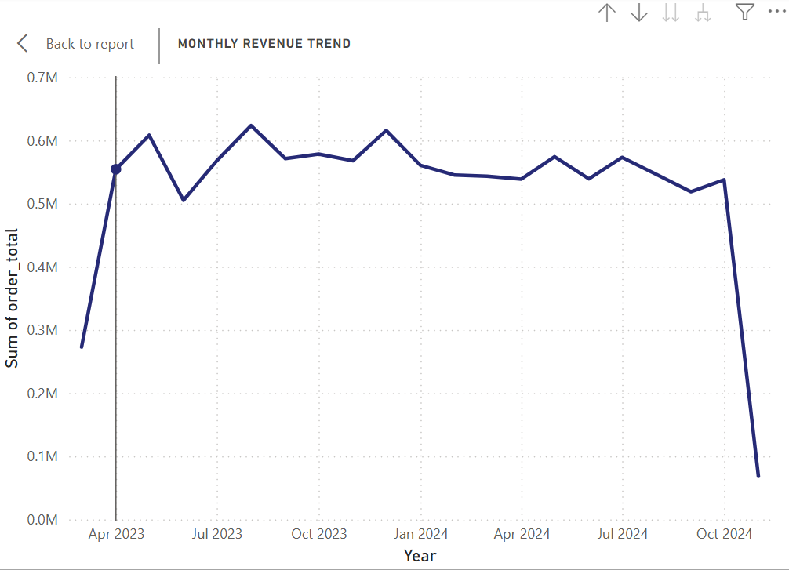

- Delivery Performance
69.4% of orders were delivered on time. However 30% of orders faced delays. 9.7% significantly delayed directly impacting customer satisfaction and retention.

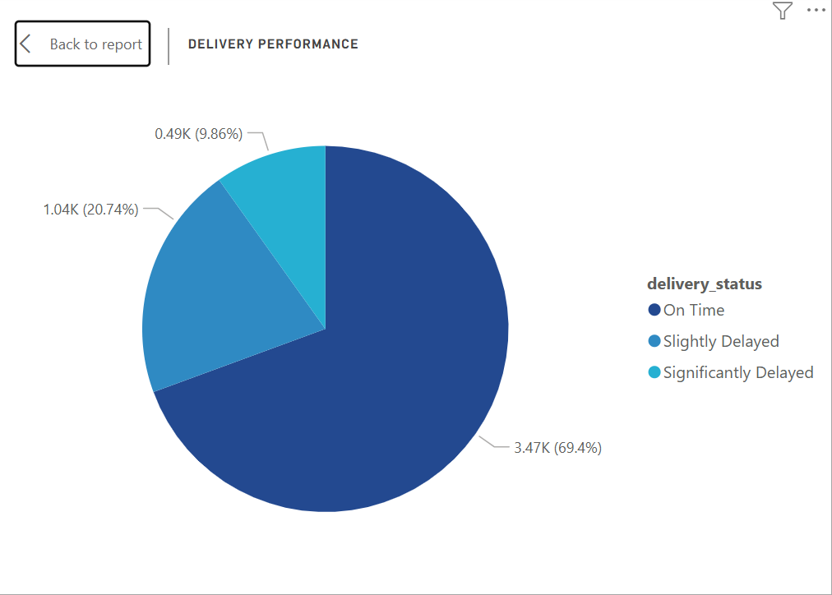

- Category Performance
Dairy and Breakfast dominates revenue while Instant and Frozen Food commands the highest profit margins. This Gap between volume leaders and margin leaders present a key strategic opportunity.

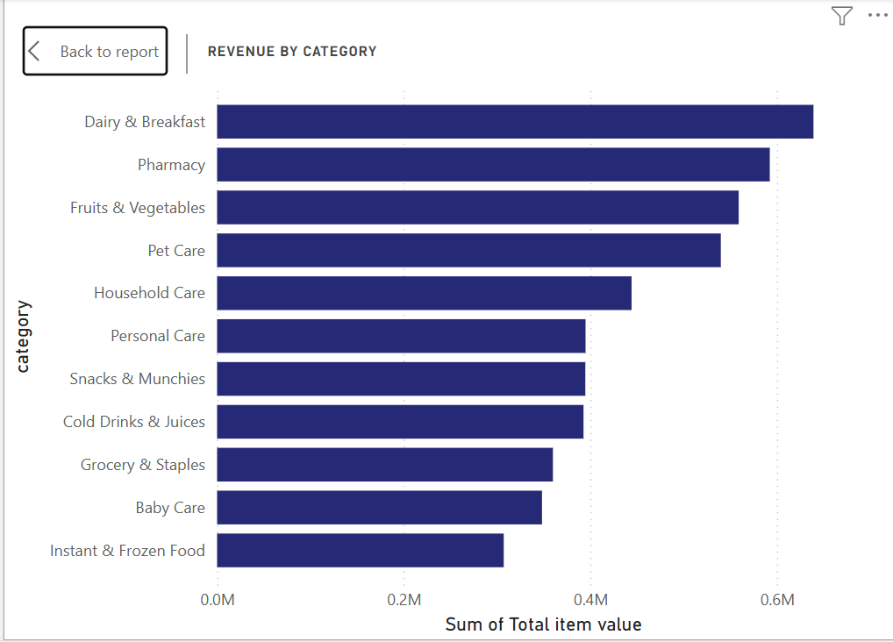

- Customer Base
24% of customers are inactive, representing a significant reactivation opportunity. 56% of customers are high value (AOV > Rs1000), indicating a predominately premium customer base.
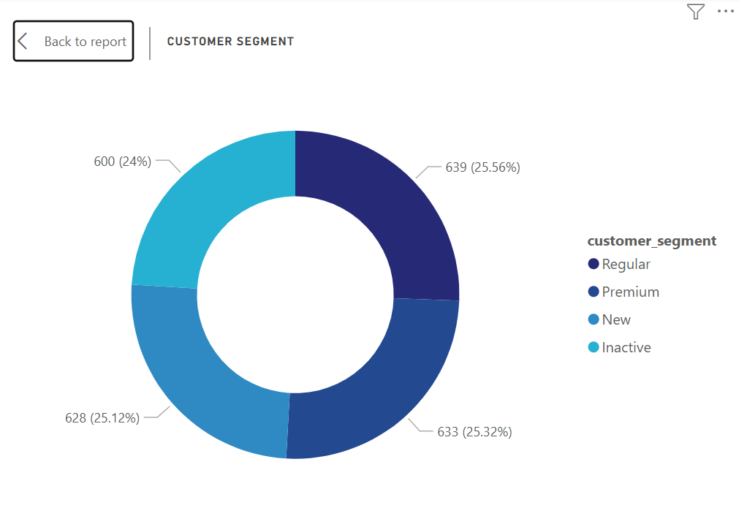

- Inventory & Damage
Household Care and Grocery & Staples have the highest damage rates, leading to preventable inventory losses. Dairy and Breakfast has the lowest damage rate despite being perishable.

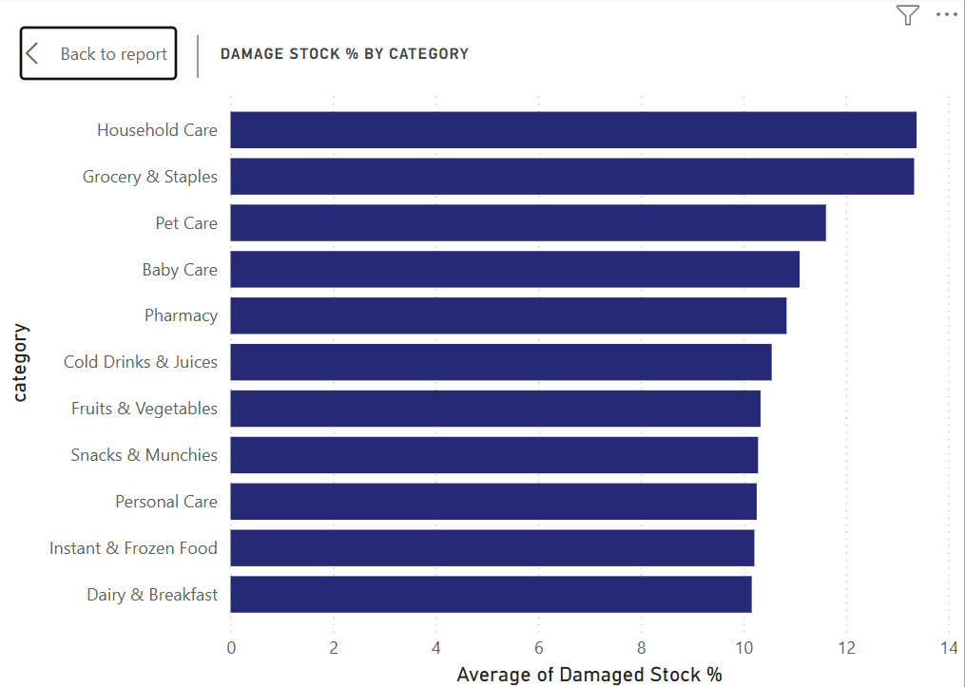

Business Recommendation

- Boost Frozen Food Visibility
Since Instant & Frozen Food has the highest margins but lowest revenue, Blinkit should increase its visibility through app promotions, homepage banners and targeted discounts to improve overall profitability.

- Reactive Inactive Customers
24% of inactive customers should be targeted with personalized reactivation campaigns like discount voucher, push notification and loyalty rewards as reactivation is significantly cheaper than new customer acquisition.

- Improve Packaging for High Demand Categories
Household Care and Grocery & Staples requires improved packaging standards to reduce damage during rapid delivery. Investing in better packaging will directly reduce inventory losses and improve margins.

Limitation
- The dataset covers March 2023 to November 2024 and may not reflect current quick commerce consumer behavior, which has evolved significantly by 2026.

- The dataset is sourced from Kaggle and may not represent actual Blinkit proprietary data as then delivery partner and store level data appeared synthetically generated with uniform performance metrics, limiting operational analysis depth.

Conclusions
This analysis demonstrates that while Blinkit shows strong revenue performance and a premium cuistomer base, significant opportunities exist in margin optimization, customer reactivation and inventory management. The analytical framework developed in this project is fully scalable to real-time data.

